KIOSK

SET UP
Guide Created by Binghamton University

KIOSK SET UP
- Screenshots Below
  - Create Event
  - Click The Event, Then Click “Track Attendance.”
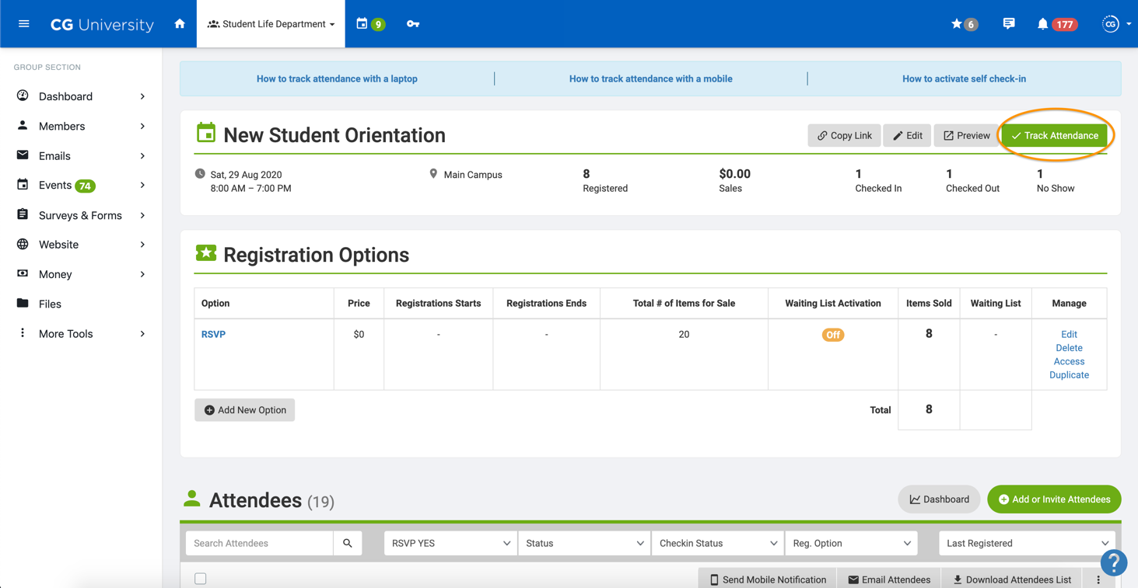
  - Select “Self Check-In Kiosk”
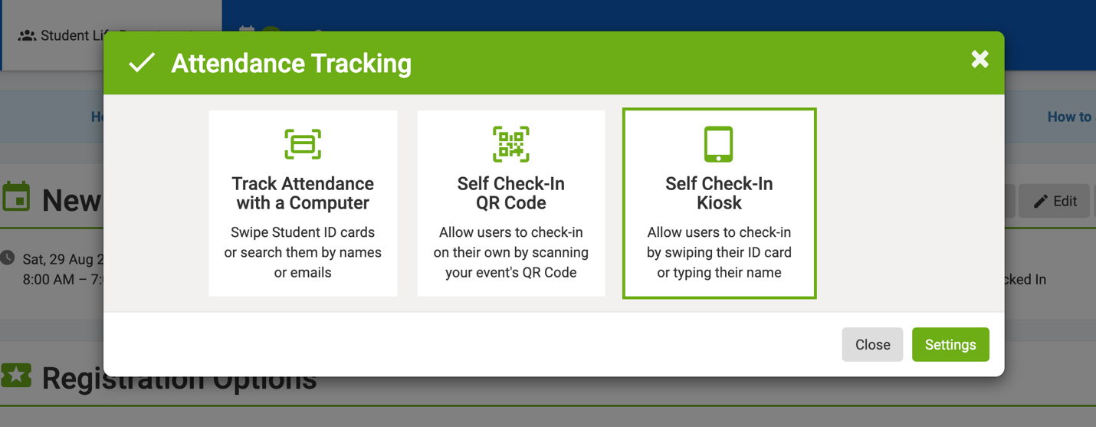

  - Click Kiosk Settings
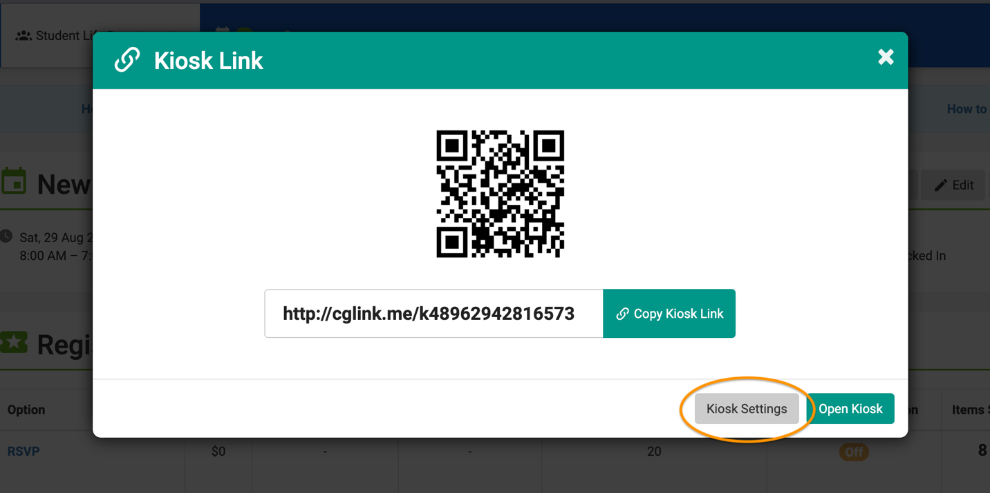
  - Under “Check-In Method…” Select “Enter name or email” & Click Save (Note - All Other Options Should Match The Screen Shot).
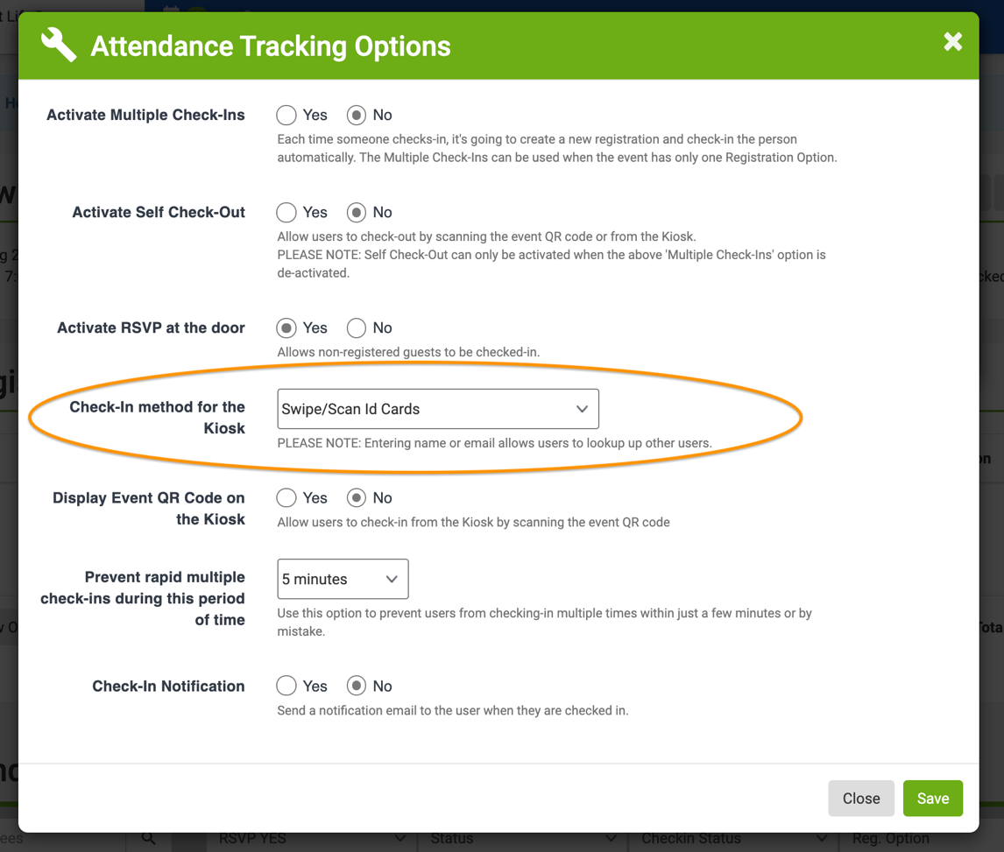
  - Select “Self Check-In Kiosk” (Yes, Again).
  - Copy Kiosk Link.
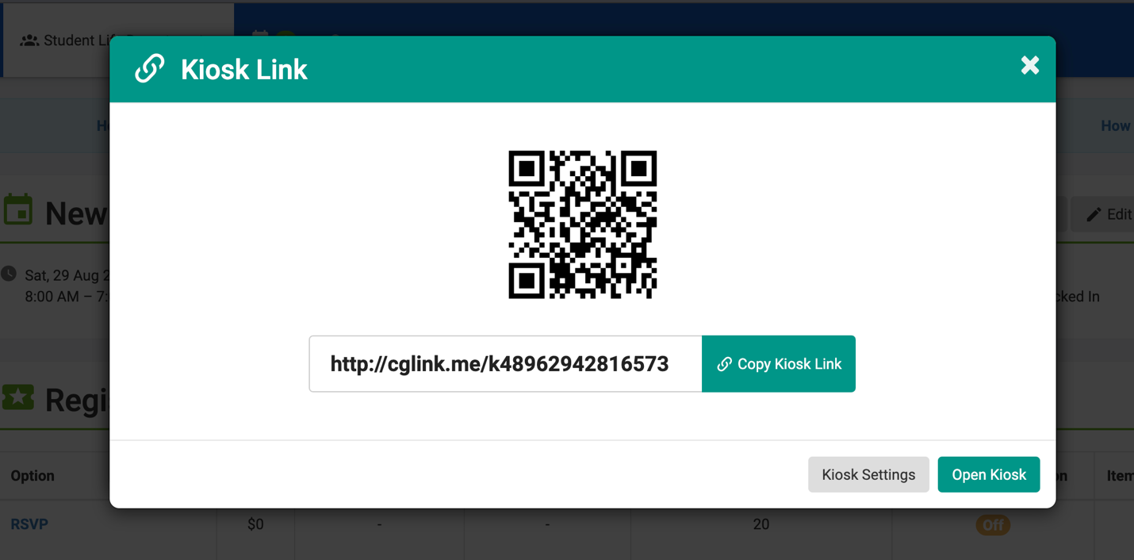
  - Paste Link in Internet Browser
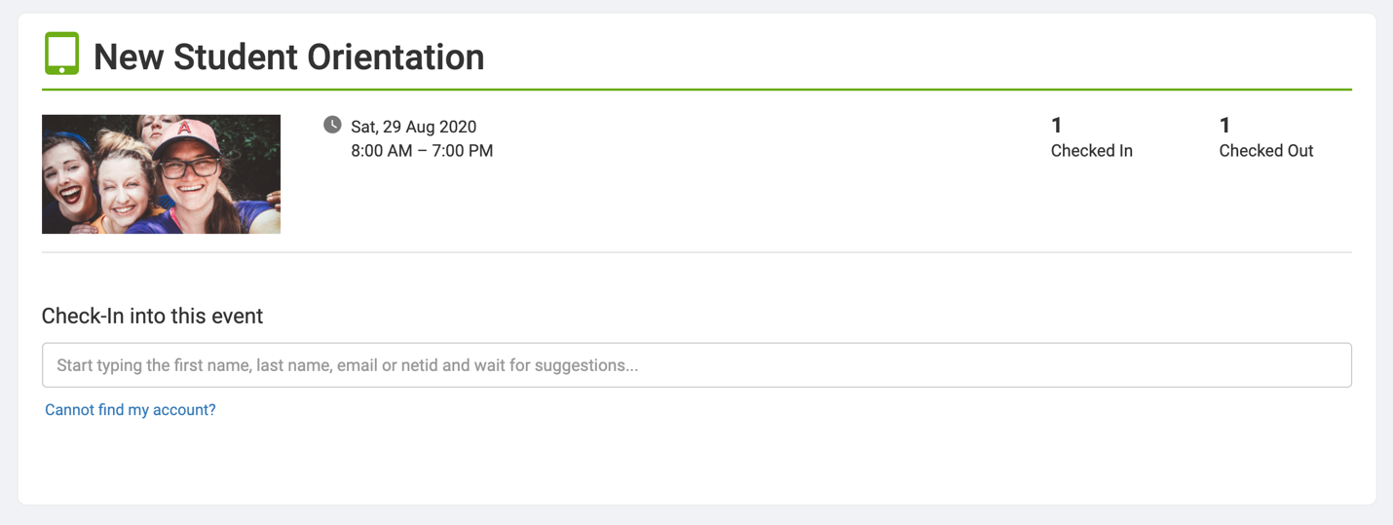

  - Begin Typing Student’s Name or Email
  - Select the User (The Kiosk Page will automatically reset after 5 seconds)
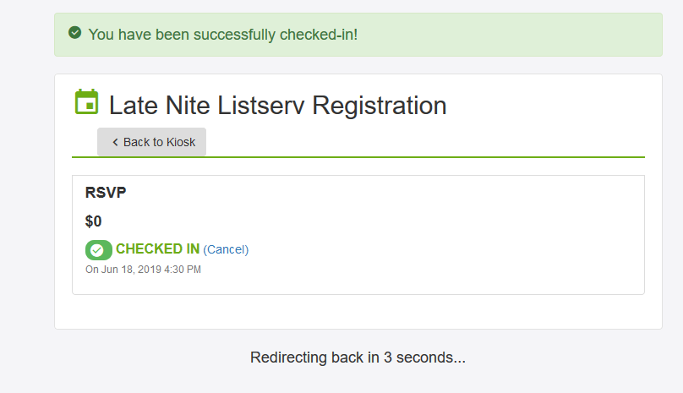

NEED ADDITIONAL HELP?
- CampusGroups Support Article:
  - How To Use The Kiosk To Track Attendance
- CampusGroups Support Video:
  - Self Check-In Methods
  - Begin at [time] 4:05
- Explore CampusGroups Resource Articles http://help.campusgroups.com.
- Click “?” on bottom right to access CampusGroups Support.
- Email campus contacts (insert campus contact emails).

