MEMBER

MANAGEMENT
Guide Created by Binghamton University

HOW TO CLOSE GROUP MEMBERSHIP
- Screenshots Below
  - How to Log Into Custom platform link.
  - Navigate To Your Group.
  - Click Your Group ‘Dashboard’
  - Click Settings
  - Click ‘Basic Information’ & Scroll Down.
  - Check ‘Yes’ Next To Close Membership.
  - Save.
- Steps 1-5
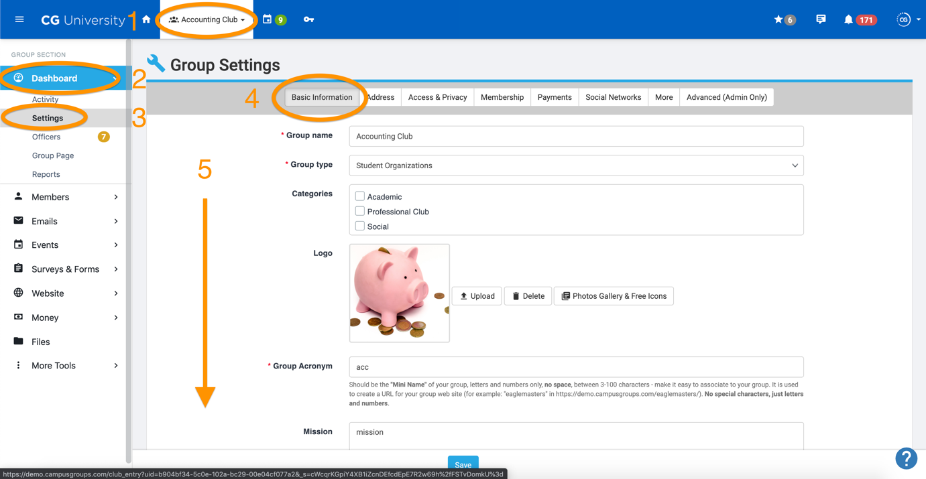
- Steps 6-7
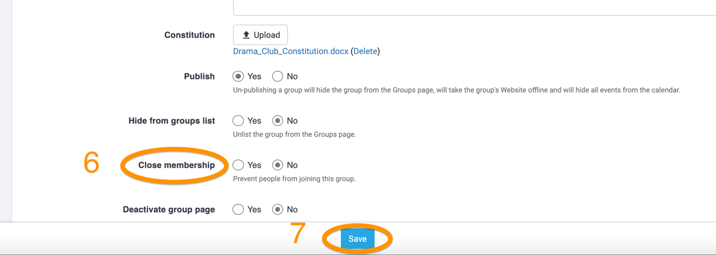

HOW TO DELETE ALL UN-VALIDATED MEMBERS
- Screenshots Below
  - How to Log Into Custom platform link.
  - Navigate To Your Group.
  - Click Click Members.
  - Click Current Members.
  - Filter for “Not Validated Members.”
  - Check The Box Above First User Name (To Select All Un-Validated Members).
  - Select 3 Dots (Top Right Corner) & Click Delete.
    - Note - Instead of deleting these individuals, consider making them your Group’s Contacts. To do this, just click the ‘Make Contact’ option instead of ‘Delete.’
- Steps 1-4
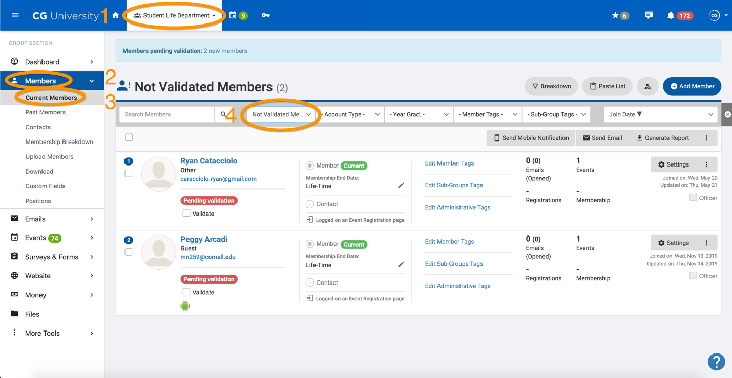

- Steps 5-7
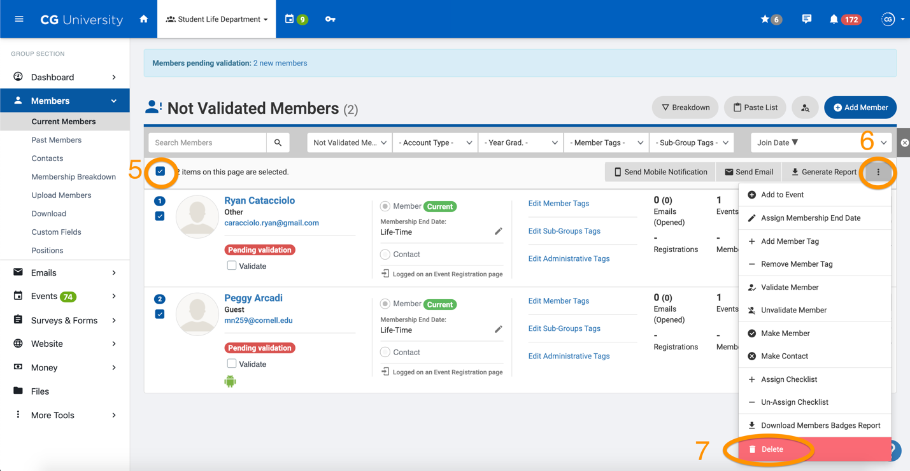

NEED MORE HELP?
- Explore CampusGroups Resource Articles http://help.campusgroups.com.
- Click “?” on bottom right to access CampusGroups Support.
- Email campus contacts (insert campus contact emails).

