MARKETING

& ROSTER OUTREACH
Guide Created by Binghamton University

HELPFUL ROSTER MANAGEMENT TOOLS
- Member Uploads
  - How To Do?
    - Individually? Group > Members > ‘Add Member’ > Add Email Of Individual (Or Multiple) Users > ‘Add.’
    - Paste An Email List? Group > Members > ‘Add Member’ > ‘Paste Emails’ > Paste User Email List > ‘Apply.’
    - In Bulk? Group > Members > ‘Upload Members’ (Under Main ‘Member’ Menu) > Download Excel Sheet > Fill It Out According To CampusGroups Instructions > Upload File.

- ‘Current Members’ Dropdown (View Different Member Types)
  - Where To Find?
    - Group > Members > Current Members Dropdown.

- ‘Contact’ Functionality
  - Where To Find?
    - Group > Members > Contacts (Under Main ‘Member’ Menu).
  - How To Do?
    - Individually? Check Bubble Next To ‘Contact’ (Near Individual Username).
    - In Bulk? Check Box (Top Left Corner) > Check Boxes Next To Contact Users > 3 Dots (Top Right Corner) > ‘Make Contact.’

- Member Tags / Sub-Group Tags
  - What’s The Difference?
    - Member Tags are back-end tags Officers assign Members. They are hidden from Members and other front-end users.
    - Sub-Group Tags are front-end tags that Officers can assign Members or Members can assign themselves/each other. They are visible to everyone.
  - Where To Find?
    - Group > Members > ‘Member Tags’ / ‘Sub-Group’ Tags Dropdown.
  - How To Do?
    - Individually? Group > Members > ‘Edit Member Tags’ / ‘Edit Sub-Group’ Tags (Next To Individual Username) > Click ‘Edit’ > Create Member Tag / Sub-Group Tag > ‘Submit.’
    - In Bulk? Same Instructions As Above (Create Tag FIRST) > Select The Other Users This Tag Applies To > 3 Dots (Top Right Corner) > ‘Add Member Tag.’

- Generate Report
  - Where To Find?
    - Group > Members > Select Members You Want A Report On > 3 Dots > ‘Generate Report.’

- Close Group Membership.
  - Instructions On Separate Cheat Sheet.

- Validate / Un-validate Members
  - Instructions On Separate Cheat Sheet.

HELPFUL EMAIL MARKETING / OUTREACH TOOLS
- Send Email From Member List
  - How To Do?
    - Group > Members > Select Members You Want To Email > ‘Send Email’ (Top Right) > Create Your Email > Send.

- Create A Mailing List
  - How To Do?
    - Group > Members > Select Sub-Groups You Want To Add To Mailing List > Click On “Save Selection As Mailing List.”

- Emails Tracking
  - Where To Find?
    - Group > Emails > Emails Tracking (Under Main ‘Member’ Menu).
  - Where To Find?
    - Group > Emails > Sent > ‘Details’ (Right Side) OR 3 Dots > Stats.

- New CampusGroups Email Builder
  - How To Do?
    - Group > Emails > Orange ‘Compose Email’ Button > Select Recipients > Orange ‘Compose Email For Selected Groups’ Button > Choose ‘Email Builder.’
- Import An Email Template
  - How To Do?
    - Group > Emails > Templates > Create Template > Copy Old Newsletter’s HTML/CSS > Paste It In The Source Of The WYSIWYG.
    - 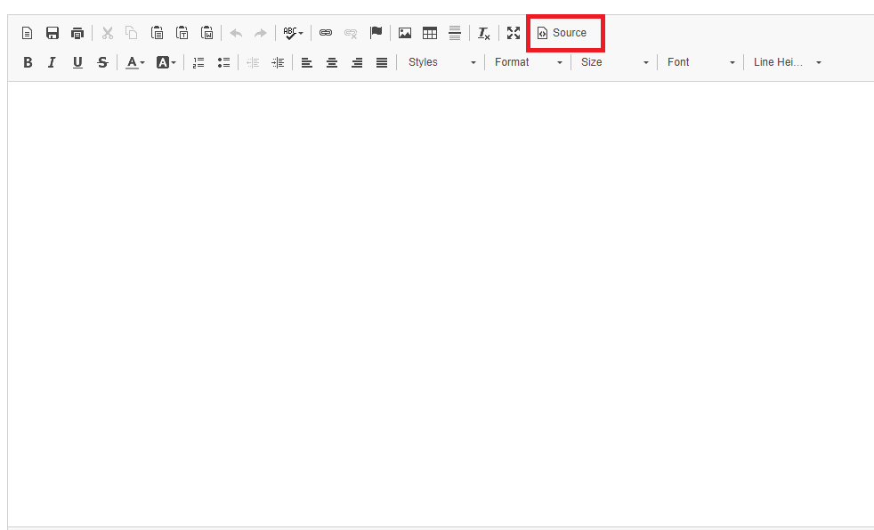

CAMPUSGROUPS ARTICLES
- Managing All Members Of A Group
- What Is The Difference Between A Member & A Contact
- How Manage Members With Tags
- How To Add New Members To Your Group
- How To Importing Members To Your Group
- How To Do A Mass Upload Of Members & Officers In Different Groups At Once
- How To Send An Email With A Template
- How To Email A List Of Contacts (Non-Members)
- How To Email Targeted Lists Of Members
- How To Add Click-boxes To Your Email
- How To Publish An Email As A Newsletter On Your Website
- How To Add News To Your Email
- How To Add Anchors To Your Emails
- How To Insert Images In Your Emails

NEED MORE HELP?
- Explore CampusGroups Resource Articles http://help.campusgroups.com.
- Click “?” on bottom right to access CampusGroups Support.
- Email campus contacts (insert campus contact emails).

